SOUTHERN STATES CORRECTIONAL ASSOCIATION
56th ANNUAL SUMMER CONFERENCE

INVITATION TO EXHIBIT
AND SPONSOR
(February 1-3, Mid-Winter)
August 14-19, 2026

Hyatt Regency
Savannah, GA

2026 Better Together
Working in Unison to Unite Corrections
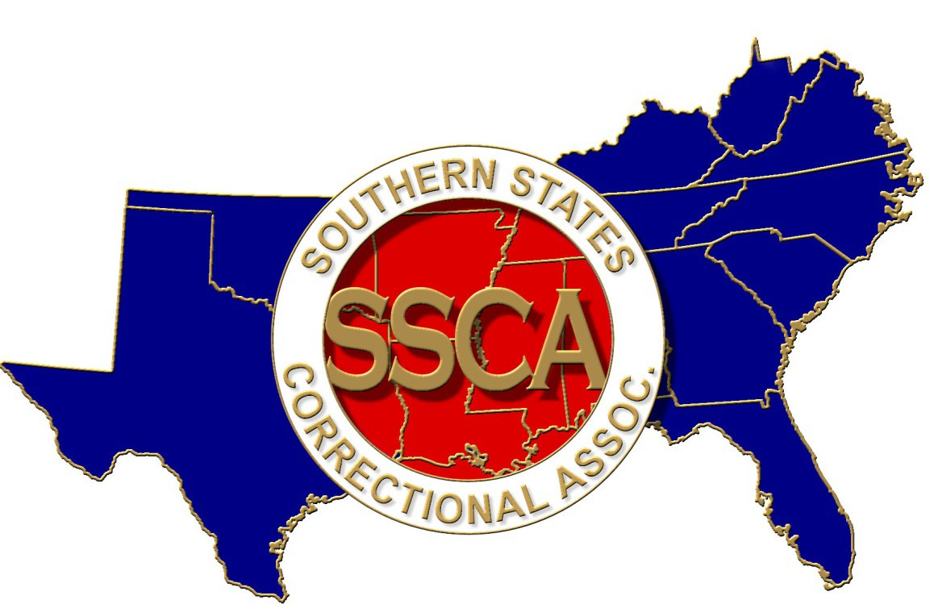
EXHIBIT SPACE AND
SPONSORSHIP INFORMATION

AN INVITATION TO EXHIBIT AND SPONSOR

ABOUT THE ASSOCIATION
The Southern States Correctional Association (SSCA) is a non-profit regional organization representing professionals in criminal justice agencies from 14 southern states. SSCA was formed in 1969 and is the most active regional organization of its kind in America. SSCA represents the interest of virtually every correctional agency, from professional workers in youth and adult services, prisons, community correction centers, probation and parole, to agency directors.

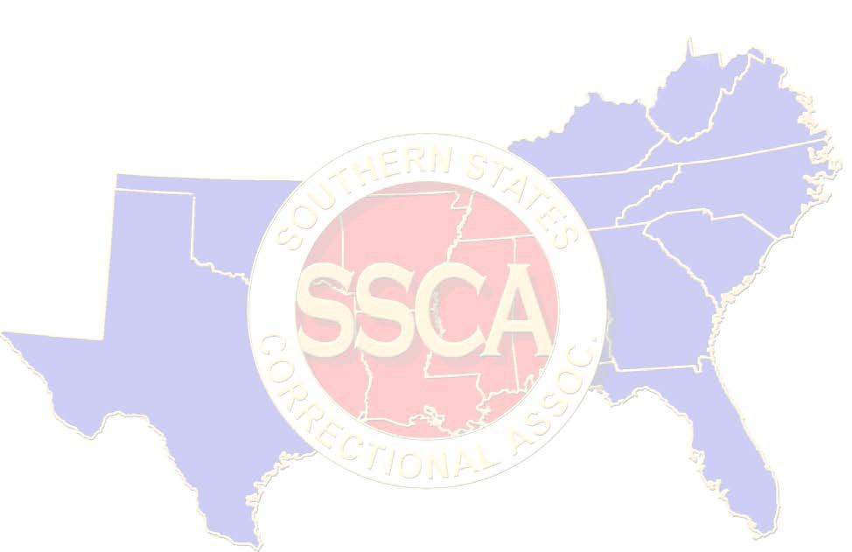
Each year the Association holds a training conference to provide an opportunity to exchange issues and ideas with other correctional professionals, to provide training by experienced speakers, and to expose correctional personnel to new and established vendors offering potential to increase their effectiveness.

APPLICATION FOR SPACE
Please make your application for exhibit space by completing the attached Agreement. All space assignments will be made on a first-come first-serve basis. Telephone requests will not be accepted. Vendor space is limited! Vendor set-up begins Saturday, August 15, 2026, at 12:00 PM, and must be completed by 4:00 PM. Take down is Monday, August 17, 2026 after the last scheduled Vendor Area event. Applications for exhibit space and program advertisements are subject to approval by the SSCA Exhibits Committee. The exhibit costs for booths are outlined in this pamphlet. All ad copies should be black and white, camera ready, submitted electronically in either high resolution PDF or JPEG format to be published in the conference program.

REGISTRATION AND HOUSING
Each exhibiting company receives one complimentary registration package per booth. Participation in meal functions requires a band for all attendees. Extra tickets may be purchased at the SSCA Registration Desk.
For more information please contact:
SSCAVendor2026@gmail.com

Renee Etheridge, Vendor/Exhibits Co-Chair

Tom McElhenney, Vendor/Exhibits Co-Chair

To make hotel reservations at the conference rate $189 + tax per night, call the Hyatt Regency Savannah at 912-225-1427. To ensure you receive the SSCA rate, be sure to mention you are with the SSCA. Deadline for the conference rate is July 23, 2026.
EXHIBITOR SERVICES
Each exhibitor will receive an exhibitor information packet approximately 30-45 days prior to the conference opening.

EVENT SPONSORSHIP/CO-SPONSORSHIP
Several events are listed in this pamphlet for vendors to sponsor or co-sponsor. These include, but are not limited to, the Golf Tournament, Awards Banquet, breaks and special activities. The sponsor will receive appropriate recognition for their sponsorship.

DOOR PRIZES
Exhibitors are encouraged to provide door prizes for our random drawings throughout the day on Monday, August 17, 2026. An exhibit worker will visit the providing vendor company, announce the company, and pull the winning name(s) for your door prize at a special event scheduled in the exhibit area.

LIABILITY
Exhibitors agree that SSCA and their respective agents will not be responsible in any way for damages, loss, or destruction of any property of exhibitor, injury of exhibitor, or exhibitor's representative(s), agency, employee(s), licensee(s) or guest(s). Exhibitor is responsible for maintaining appropriate property and liability insurance.

SPACE CANCELLATIONS
In the event the conference is postponed or canceled, due to any occurrence not occasioned by the conduct of the SSCA, such as an Act of God or uncommon event, the performance of the parties under this agreement will be excused from all debts and obligations. A refund by SSCA will occur, less a pro-rated share of expenses actually incurred by the Association. Should the exhibitor cancel space prior to July 1, 2026, for the Summer Conference, SSCA shall retain 50% of the exhibit fee. If the exhibitor cancels after July 1, 2026, for the Summer Conference, SSCA will retain 100% of the exhibit fee.

EXHIBIT INFORMATION ATTACHMENT 1

EXHIBIT SPACE
(Exhibit Booth will be equipped with 8’ high back drape, 3’ high side divider drape, 6’skirted table, and two chairs)
(X) |  | Fee
 | 10’ x 8’ Exhibit Space | $900
 | 10’ x 8’ Exhibit Space & Quarter Page Ad | $950
 | 10’ x 8’ Exhibit Space & Half Page Ad | $975
 | 10’ x 8’ Exhibit Space & Full-Page Ad | $1,000
 | 20’ x 8’ Exhibit Space & Full-Page Ad | $1.800
 | Half Page Ad | $175
 | Full Page Ad | $375

*NOTE: Program Advertisement must be submitted via e-mail to Antonio.Johnson@gdc.ga.gov by June 15, 2026. Program advertisements must be camera ready, high resolution PDF, or JPG
Advertising Opportunities | (X)
Four (4) full-page advertisements in the SOUTHERN CONCOURSE |  | $1,750 | each
Four (4) half-page advertisements in the SOUTHERN CONCOURSE |  | $1,350 | each
Full Page Ad in Conference Program |  | $375
Half Page Ad in Conference Program |  | $190
Quarter Page Ad in Conference Program |  | $100

TOTAL AMOUNT FOR EXHIBIT SPACE / ADVERTISING:

EXHIBITOR PARTICIPATION

Company Name
(As it should appear on booth sign)
Address:
(To send booth information)
City: |  |  |  |  | State | Zip Code
Contact Name:
E-mail address:
Contact Phone Number:
Exhibitor Representatives
Product(s)/Service(s)

SIGNATURE OF AUTHORIZED AGENT FOR EXHIBITING COMPANY |  | DATE
PRINT OR TYPE NAME OF AUTHORIZED AGENT |  | PRINTED E-MAIL

Make checks payable to SSCA GA, and submit all payments and attach Sponsorship Opportunities (Attachment 1), and Exhibit Information (Attachment 2) to:
Renee Etheridge
GA DOC
300 Patrol Rd.
Forsyth, GA 31029
To learn more about the Southern States Correctional Association (SSCA) please visit our website at: sscaweb.org
ATTACHMENT 2
SPONSORSHIP OPPORTUNITIES
Take this opportunity to put your company in the spotlight by becoming a Conference Event Sponsor. All sponsors will be recognized in our conference program and on signage at the event. You will receive positive media attention from your association with the SSCA.

SPONSORSHIP OPPORTUNITIES (August 2026)
Event | Quantity Needed | Quantity Sponsored | (X) | Sponsor Amount
Opening Ceremony (Sunday Night) | 1 |  |  | $10,000
Annual Training Conference Speakers | 10 |  |  | $800 | Each
Breakfast | 4 |  |  | $4,000 | Each
Refreshment Break | 6 |  |  | $500 | Each
Lunch for Conference Participants | 2 |  |  | $7,000 | Each
Past President’s Breakfast | 1 |  |  | $1,500
Lunch for Executive Board | 1 |  |  | $2,000
State Rep Outing | 1 1 1 111111111111 |  |  | $1,000
Sunday Riverstreet Scavenger Hunt | 1 |  |  | $4,500
President’s Reception (held in the Exhibit Hall) | 1 |  |  | $25,000
Georgia Night (Monday Night) | 1 |  |  | $25,000
Virginia Night (Tuesday Night) | 1 |  |  | $3,000
Awards Banquet (Tuesday Night) | 1 |  |  | $35,000
Hospitality Room | 4 |  |  | $2,500 | Per Night
Golf Tournament (Sunday) | 1 |  |  | $2,500

Conference Shirts (for all conference participants with Sponsor's Name) |  | $5,000
Host Committee Shirts |  | $2,000

TOTAL AMOUNT SPONSORED:
Sponsorship Recognition

All sponsors will be recognized in our conference program and on signage at the event. Recognition amounts are determined by a combination of Conference Sponsorship, Association Sponsorship, and advertising.

DIAMOND SPONSORS - $10,000 +

- Exhibit space in the special recognition area
- Full page color ad in the Annual Conference Program - NOTE: Program Advertisement must be submitted via e-mail to dcampbel@corrections.state.la.us Program advertisements must be camera ready, high resolution PDF, or JPG.
- Special recognition at the Annual Conference Awards Banquet with 4 RESERVED SEATS
- Supporting Patron Membership in SSCA
- Article in the “SOUTHERN CONCOURSE” recognizing contribution
- FOUR (4) CONFERENCE REGISTRATION PACKETS WITH EVENT TICKETS, UPON REQUEST

GOLD SPONSORS - $5,000 - $9,999

- Recognition in the Annual Conference Program
- Special recognition at the Annual Conference Awards Banquet
- Supporting Patron Membership in SSCA
- Article in the “SOUTHERN CONCOURSE” recognizing contribution
- TWO (2) CONFERENCE REGISTRATION PACKETS WITH EVENT TICKETS, UPON REQUEST

SILVER SPONSORS - $3,000 - $4,999

- Recognition in the Annual Conference Program
- Special recognition at the Annual Conference Awards Banquet
- TWO (2) CONFERENCE REGISTRATION PACKETS WITH EVENT TICKETS, UPON REQUEST

BRONZE SPONSORS - $1,200 - $2,999

- Recognition in the Annual Conference Program
- TWO (2) CONFERENCE REGISTRATION PACKETS WITH EVENT TICKETS, UPON REQUEST

