

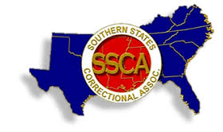

2026 SSCA SUMMER ANNUAL TRAINING CONFERERENCE- HYATT REGENCY SAVANNAH
2 West Bay St. Savannah, GA 31401 August 14-19, 2026

When you submit this form, it will not automatically collect your details like name and email address unless you provide it yourself.
* Required

Last Name, First Name *

Title- Agency/ Facility *

Business Address *

City, State, Zip Code *

Phone Number *

Email Address *

Special Accommodations/ Vegetarian Meal Request/ Other Dietary Needs *

VETERAN *
(For recognition purposes)  YES
NO

REGISTRATION FEES *
Fees include all hospitality, meals and events.

SSCA MEMBER- $200.00 NON-MEMBER-$250.00
Late Registration-Fees- $235.00 PAST PRESIDENT

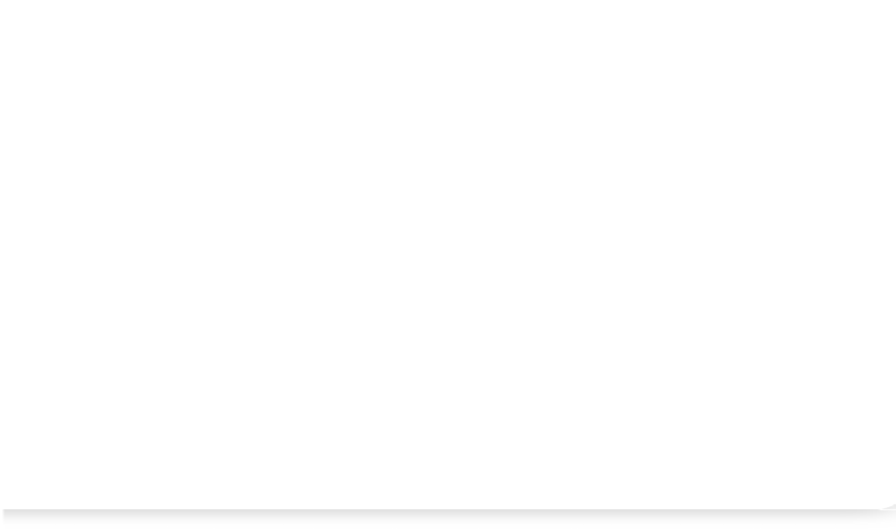



SPEAKER OR PRESENTER EXHIBITOR OR SPONSOR

- REGISTRATION FEES PAYABLE NOTE: PLEASE ENSURE PAYMENT IS PROVIDED WITH REGISTRATION *
Make checks payable to SSCA GA CHAPTER - Send to Georgia Department of Corrections -

P.O. Box 1529 Forsyth, GA 31029- Attn: Renee Etheridge

CHECK/ MONEY ORDER PAYPAL
Other

This content is created by the owner of the form. The data you submit will be sent to the form owner. Microsoft is not responsible for the privacy or security practices of its customers, including those of this form owner. Never give out your password.
Microsoft Forms | AI-Powered surveys, quizzes and polls Create my own form
The owner of this form has not provided a privacy statement as to how they will use your response data. Do not provide personal or sensitive information. | Terms of use

